**Samsung Battery Pack**

EB-P1100BSEGWW

[**Product Ratings :4.0(Number of Ratings :25)**](javascript:void(0))

* Dual port
* Sleek design
* Fast charging

**Choose your color**

**Color :**Silver

* 

**Samsung Battery Pack**

Silver

[**Where to buy**](javascript:;)

**Charge fast on the move**

The new Samsung Battery Pack comes with Samsung AFC (15W) and Quick Charge 2.0 support that lets you power up quick when you’re on the go. And with OCP functionality, you can charge safely without having to worry about excessive current levels damaging your device.

Charge fast on the move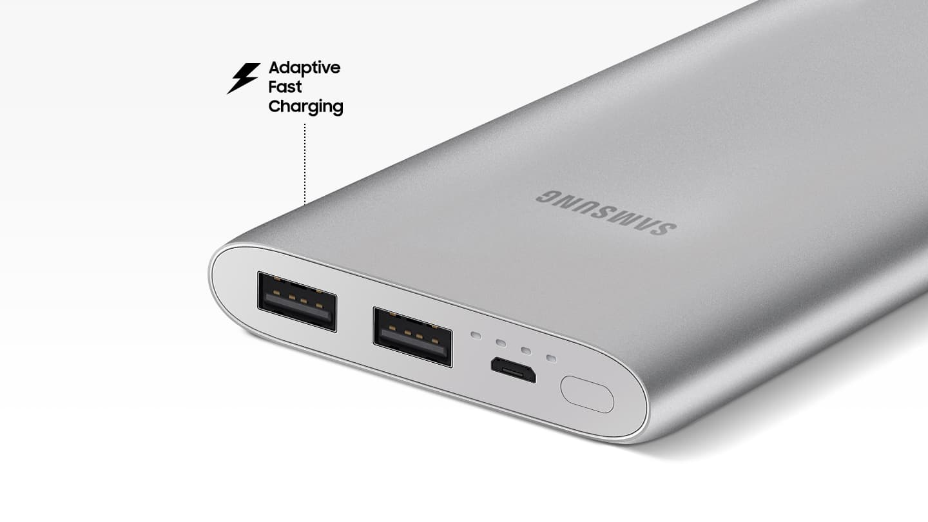

*Output Overcurrent Protection (OCP): OCP monitors output current and shuts off when current exceeds the maximum limit that your device can withstand.

**Top up quick**

Recharges fast so you can reuse even faster. Samsung Battery Pack prevents overvoltage with OVP so it can be safely recharged to full capacity in just 220mins in fast-charging mode. Now you can get back to enjoying your device quicker than previous models.

Top up quick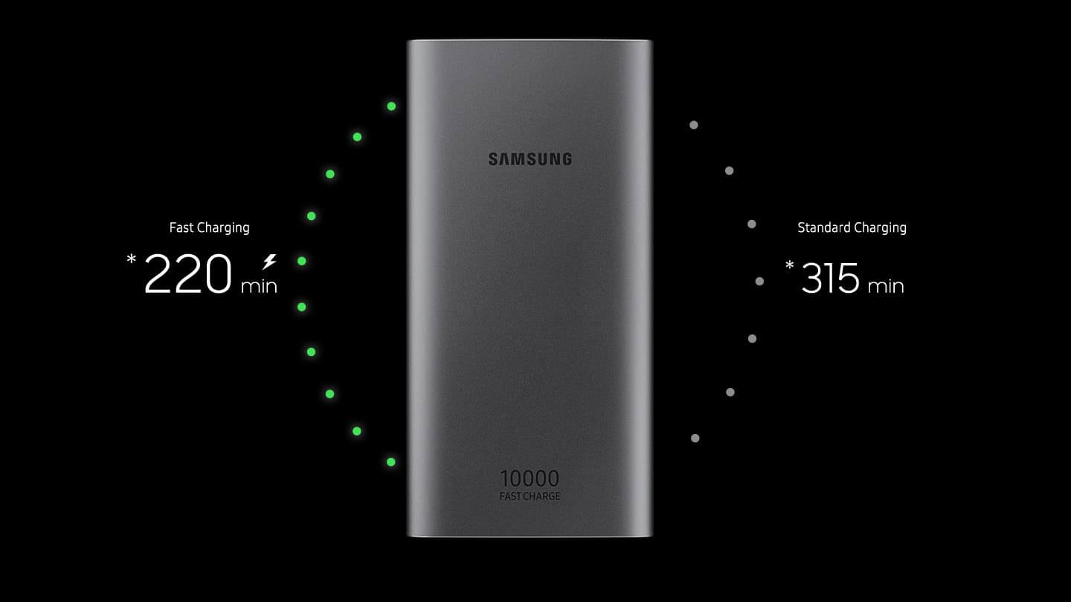

*Based on Samsung internal tests. Results may vary based on usage environment.  
**Input Overvoltage Protection(OVP): OVP circuit prevents unexpected voltage surges from damaging your device.

**Charge with double the efficiency**

Twice the advantage. Thanks to its dual-port charging capability, Samsung Battery Pack can power two devices simultaneously for added convenience and far less hassle.

**Samsung Battery Pack**

EB-P1100BSEGWW

[**Product Ratings :4.0(Number of Ratings :25)**](javascript:void(0))

* Dual port
* Sleek design
* Fast charging

**Choose your color**

**Color :**Silver

* 

**Samsung Battery Pack**

Silver

[**Where to buy**](javascript:;)

**Charge fast on the move**

The new Samsung Battery Pack comes with Samsung AFC (15W) and Quick Charge 2.0 support that lets you power up quick when you’re on the go. And with OCP functionality, you can charge safely without having to worry about excessive current levels damaging your device.

Charge fast on the move

*Output Overcurrent Protection (OCP): OCP monitors output current and shuts off when current exceeds the maximum limit that your device can withstand.

**Top up quick**

Recharges fast so you can reuse even faster. Samsung Battery Pack prevents overvoltage with OVP so it can be safely recharged to full capacity in just 220mins in fast-charging mode. Now you can get back to enjoying your device quicker than previous models.

Top up quick

*Based on Samsung internal tests. Results may vary based on usage environment.  
**Input Overvoltage Protection(OVP): OVP circuit prevents unexpected voltage surges from damaging your device.

**Charge with double the efficiency**

Twice the advantage. Thanks to its dual-port charging capability, Samsung Battery Pack can power two devices simultaneously for added convenience and far less hassle.